**Table of Content**

Abstract 2

Oral Disease Detection App 2

Purpose 2

Introduction 2

Benefits of the Proposed System 3

Data Source and Analysis Process 3

Data Source 3

Analysis Process 4

Output Interpretation: 5

Transformers 5

Pros of Transformers in Vision Tasks 5

Cons of Transformers in Vision Tasks 6

Steps to Integrate Transformers with CNNs 6

Model Architecture 7

Model Prediction Results 7

1. Calculus 7

2. Data Caries 7

3. Gingivitis 7

4. Mouth Ulcer 7

5. Tooth Discoloration 7

6. Hypodontia 7

Key Observations from the Output: 8

1. Hypodontia: 82.37% confidence. 8

2. Data Caries: 85.75% confidence. 8

3. Mouth Ulcer: 99.94% confidence. 8

4. Calculus: 99.37% confidence. 8

5. Gingivitis: 80.34% confidence. 8

Training and Validation Accuracy 9

Training and Validation Loss 9

Key Issues 9

Conclusion 11

**Abstract**

The Oral Disease Detection App is an innovative digital solution designed to improve oral health management by leveraging artificial intelligence. The app enables users to upload images of their oral cavity for AI-powered disease detection and receive actionable insights through a chatbot, powered by Google's Gemini-Pro AI. Built with TensorFlow for disease prediction and Streamlit for a user-friendly interface, the app enhances accessibility, particularly for individuals with limited access to dental care. Key benefits include early detection and prevention of oral diseases, educational empowerment through tailored advice, and cost-effective, instant diagnostics. The system emphasizes secure, personalized user experiences, fostering better oral hygiene and timely interventions to reduce potential health complications.

**Keywords:**

Oral health, disease detection, AI-powered diagnosis, TensorFlow, Streamlit, oral hygiene, early detection, dental care, chatbot integration, Gemini-Pro AI, image-based diagnosis, health accessibility, preventative care, cost-effective diagnostics, personalized health solutions.

**Oral Disease Detection App**

**Purpose**

The purpose of the Oral Disease Detection App is to provide an innovative platform that utilizes machine learning and artificial intelligence to identify potential oral health issues from uploaded images. It aims to empower users with accurate health insights and personalized recommendations to improve their oral hygiene and overall health.

**Scope**

1. **Disease Detection**: Detect common oral conditions such as Calculus, Data Caries, Gingivitis, Mouth Ulcers, Tooth Discoloration, and Hypodontia using machine learning algorithms for image-based analysis.
2. **Health Recommendations**: Provide users with tailored suggestions for managing detected conditions and encouraging proactive oral care.
3. **AI Chatbot Integration**: Enable users to interact with an AI assistant for health tips, queries, and a personalized experience.
4. **User Authentication**: Ensure secure access through user-friendly signup and login systems.
5. **Educational Resource**: Act as a platform for spreading oral health awareness and aiding in the early detection of dental issues.

**Introduction**

Oral health is a critical component of overall well-being, yet access to dental care can be limited due to geographic, financial, or informational barriers. The Oral Disease Detection App aims to bridge this gap by offering a digital solution that leverages artificial intelligence to detect oral diseases from images uploaded by users. By combining disease detection capabilities with an AI chatbot, the app provides users with actionable insights and guidance, making oral health management more accessible and informed.

The app is built on a foundation of modern technologies, including TensorFlow for disease prediction and Google’s Gemini-Pro AI for chatbot interaction. A seamless user interface powered by Streamlit ensures ease of use, catering to individuals with minimal technical expertise.

**Benefits of the Proposed System**

* **Enhanced Accessibility:**

Provides a convenient platform for users to detect oral diseases from the comfort of their homes.

Reduces the need for frequent in-person dental visits for preliminary checks.

* **Early Detection and Prevention:**

Promotes early identification of common oral health issues, preventing potential complications.

Encourages timely intervention and professional consultation when needed.

* **Educational Empowerment:**Increases awareness about oral hygiene and the importance of preventive care. Offers suggestions tailored to specific conditions, empowering users with actionable advice.
* **Cost-Effective Solution:**Minimizes initial costs associated with dental diagnostics by offering a free or low-cost alternative. Saves time and resources for users by providing instant results and guidance.
* **AI-Powered Assistance:**Features an intelligent chatbot to address user queries, enhancing the user experience.Provides insights and tips for maintaining optimal oral health.
* **Secure and Personalized:**Ensures user data is protected through secure login mechanisms.Delivers personalized recommendations based on individual health concerns and detected conditions.

**Data Source and Analysis Process**

**Data Source**

**Dataset Description:** The dataset comprises 11,887 images categorized into six classes: Calculus, Data Caries, Gingivitis, Mouth Ulcer, Tooth Discoloration, and Hypodontia.

**Training and Validation Split:**

Training Set: 10,699 images.

Validation Set: 1,188 images.

**Image Resolution:** Each image is resized to 256x256 pixels for uniformity during analysis.

**Data Accessibility:** The dataset is stored on Google Drive and can be accessed via the provided link: Dataset Link.

<https://drive.google.com/drive/folders/1HjsX7unzqlAGNfM8OxvNwd5j0R5oGYPA>

Figure 1 shows sample data from the dataset used for oral disease detection. The samples are categorized into different classes based on the type of oral condition. Here’s a breakdown of what the image represents:

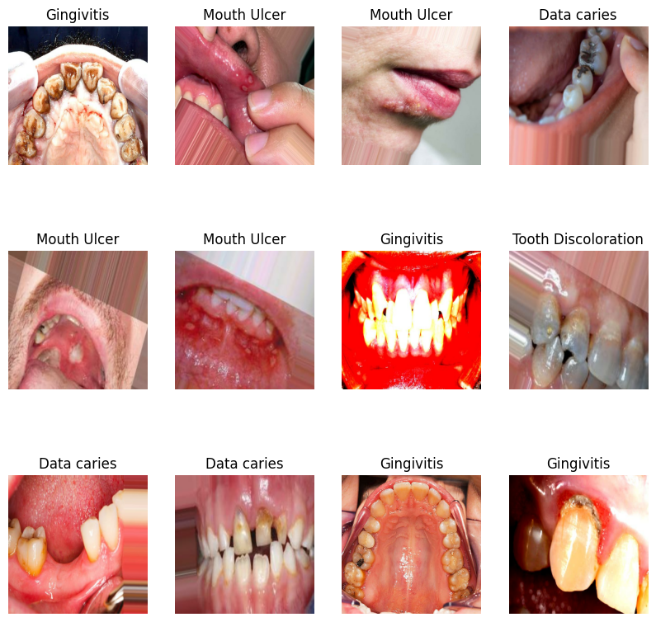

**Figure 1:** sample of Data

**Classes Represented**

**Gingivitis:** Inflammation and redness of the gums.

**Mouth Ulcer:** Open sores inside the mouth.

**Data Caries:** Decayed areas in teeth (cavities).

**Tooth Discoloration:** Visible discoloration or staining on teeth.

**Visual Characteristics:**Each row contains examples of various conditions, highlighting the diversity in their appearance.

Images showcase different angles and lighting conditions, representing the real-world variability in the dataset.

**Purpose:**These samples are likely part of an exploratory data analysis to visualize the dataset distribution and observe distinguishing features for each class.

This visualization helps in understanding class diversity, which is essential for designing robust machine learning models.

**Challenges Noted:** The dataset contains significant visual variation, such as lighting conditions, angles, and image quality, which must be addressed through preprocessing and data augmentation to improve model generalization.

**Analysis Process**

**Data Preprocessing:**Rescaling pixel values to normalize image data.Data augmentation techniques, such as flipping and rotation, applied to improve model generalization.

**Exploratory Data Analysis:**Visualization of image samples for each class to understand the dataset distribution.

**Example** image classes include "Mouth Ulcer" and "Gingivitis," displaying significant visual variations.

**Model Training:**Deep learning models are trained on the dataset to classify the six categories.

Training uses 10,699 images while maintaining a separate 1,188-image validation set for unbiased evaluation.

**Evaluation Metrics:**Accuracy, precision, recall, and F1-score calculated to assess model performance.

Confusion matrices generated to analyze class-wise detection accuracy.

**Output Interpretation:**

Predicted classes mapped back to the six disease categories.

A user-friendly interface displays these results, coupled with health recommendations.

Recommended Implementation Location

To maximize impact, the Oral Disease Detection App could be implemented in the following settings:

**Dental Clinics:** Enhance patient diagnosis efficiency and enable early detection of oral diseases.

**Community Health Centers:** Provide accessible oral health diagnostics to underserved populations.

**Schools and Universities**: Educate students on oral hygiene while offering a tool for early disease detection.

**Mobile Health Camps:** Deploy the app as part of rural and remote area health outreach programs.

**Home Use:** Allow individuals to self-assess oral health conditions and seek timely medical advice.

**Transformers**

Transformers are deep learning architectures that utilize self-attention mechanisms to capture global dependencies in data, excelling at tasks like natural language processing and computer vision. They process inputs as sequences, enabling rich feature representations and long-range context understanding.

**Pros of Transformers in Vision Tasks**

**Global Context Understanding:**Transformers excel at capturing long-range dependencies through their self-attention mechanism, unlike CNNs, which rely on local filters.

This ability to process the entire input at once enhances their performance in tasks requiring a holistic view, such as image classification or segmentation.

**Improved Feature Representation:**By processing data globally, transformers generate richer and more nuanced feature representations. This complements CNNs, which excel at extracting localized features.

**Flexibility with Input Sizes:**Unlike CNNs, transformers can handle variable input sizes without requiring strict resizing, making them versatile for datasets with inconsistent dimensions.

**Attention Mechanisms:**Attention layers allow the model to focus on the most relevant parts of the input, improving accuracy and interpretability in vision tasks.

**Enhanced Robustness:**Transformers have shown resilience to variations in input data, such as noise and occlusions, making them suitable for real-world applications.

**State-of-the-Art Results:**In vision tasks like object detection (e.g., DETR), combining transformers with CNNs has produced significant improvements over traditional architectures.

**Cons of Transformers in Vision Tasks**

**Increased Computational Complexity:**The self-attention mechanism scales quadratically with input size, demanding significant computational resources and longer training times.

**Memory Consumption:**Processing high-resolution images with transformers requires substantial memory, often limiting batch sizes and slowing down experiments.

**Overfitting Risk:**The high number of parameters in transformers increases the risk of overfitting, especially on small datasets, necessitating regularization techniques like dropout or data augmentation.

**Complexity in Architecture:**Combining transformers with CNNs introduces architectural complexity, making implementation and debugging more challenging.

**Limited Inductive Bias:**CNNs have an inherent spatial inductive bias, which helps capture hierarchical structures in images. Transformers, treating inputs as sequences, require more data to learn these patterns effectively.

**Training Instability:**Transformers are sensitive to hyperparameter tuning, such as learning rates and weight initialization, leading to potential instability during training.

**Latency in Inference:**The computational demands of transformers can result in slower inference, which may not be ideal for real-time applications.

**Steps to Integrate Transformers with CNNs**

**Create a Patch Extraction Layer:**Divide the input image into smaller patches (e.g., 16x16) and flatten them into vectors. This converts the spatial data into a sequence-like representation compatible with transformers.

Add positional encodings to retain spatial information.

**Add a Transformer Block:**Incorporate a transformer architecture with self-attention and feedforward layers. This block processes the sequence of patches to capture global dependencies and relationships.

**Combine with CNN Layers:**

Use CNN layers for initial feature extraction from the image. The extracted features can then be passed as input to the transformer block for further refinement.

Alternatively, use the transformer to process the patches and combine its output with CNN-derived features for classification.

**Proceed to Dense Layers:**After the transformer and CNN layers, pass the output through dense layers for tasks like classification or regression.

**Model Details**

The designed model is a sequential Convolutional Neural Network (CNN) for multi-class image classification. It processes images with specific dimensions defined by (IMAGE_SIZE, IMAGE_SIZE, CHANNELS) and predicts one of six classes.

**Model Architecture**

**Input Layer:**Accepts images of shape (IMAGE_SIZE, IMAGE_SIZE, CHANNELS).

**Convolutional Layers:**Six convolutional layers, each using a ReLU activation function for non-linearity.

The kernel size is set to (3, 3) to capture spatial hierarchies effectively.

MaxPooling layers with a pool size of (2, 2) follow each convolutional layer to reduce spatial dimensions and extract dominant features.

**Flatten Layer:**Converts the multi-dimensional feature maps into a single vector for the fully connected layers.

**Two dense layers:**A hidden dense layer with 64 units and ReLU activation for learning abstract features.An output dense layer with n_classes (6) units and softmax activation for probability distribution across the six classes.

**Summary**

The model consists of a combination of convolutional, pooling, and fully connected layers, making it suitable for image classification tasks.

Output layer uses the softmax activation to predict the probability for each of the six classes.

**Model Prediction Results**

**Input to the Model:**The model takes preprocessed images resized to (IMAGE_SIZE, IMAGE_SIZE, CHANNELS) as input.

**Output:**

For each image, the model predicts one of six classes:

1. Calculus
2. Data Caries
3. Gingivitis
4. Mouth Ulcer
5. Tooth Discoloration
6. Hypodontia

**Example Prediction Flow:**An image of a decayed tooth is passed into the model.

The model outputs a probability distribution across all six classes, with the highest probability corresponding to "Data Caries."

**Evaluation:**Metrics like accuracy, precision, recall, and F1-score will assess the prediction quality on the validation dataset.

A confusion matrix will provide insight into class-wise prediction performance.

The Sample Output of model Prediction is here:

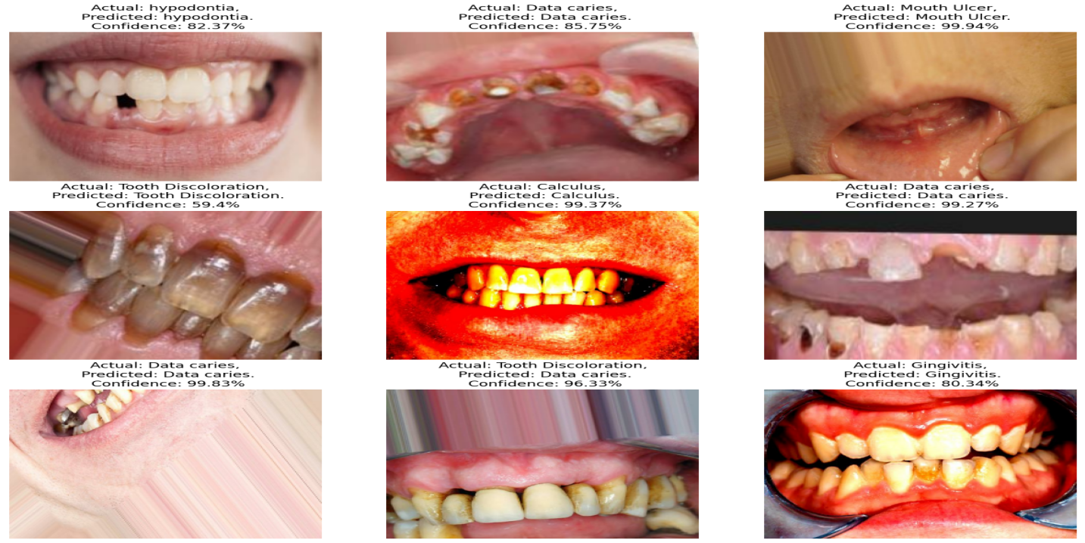

**Figure 2:** Model Prediction Sample

The **Figure 2** shows a grid of outputs from a machine learning model designed to predict dental conditions based on oral images. Each cell in the grid contains:

**Actual Diagnosis:** The true label of the condition depicted in the image (e.g., hypodontia, data caries, tooth discoloration, etc.).

**Predicted Diagnosis:** The model's prediction of the condition.

**Confidence Score: The** model's confidence in its prediction, represented as a percentage.

**Key Observations from the Output:**

**Model Accuracy and Confidence:**Most predictions are correct and have high confidence (above 80%), indicating a well-trained model.

However, one instance (Tooth Discoloration with 59.4%) has lower confidence, suggesting the model might be uncertain or the features overlap with other conditions.

**Correct Predictions:**

Examples where the actual condition matches the predicted condition:

1. Hypodontia: 82.37% confidence.
2. Data Caries: 85.75% confidence.
3. Mouth Ulcer: 99.94% confidence.
4. Calculus: 99.37% confidence.
5. Gingivitis: 80.34% confidence.

**Potential Model Limitations:**While most predictions are correct, some conditions with similar features (e.g., Tooth Discoloration and Data Caries) might cause confusion for the model.

**For example:**In one case, Tooth Discoloration was predicted correctly but with only 59.4% confidence, suggesting ambiguity.

Another case predicted Data Caries for Tooth Discoloration with high confidence, indicating potential misclassification.

**Training and Validation Accuracy**

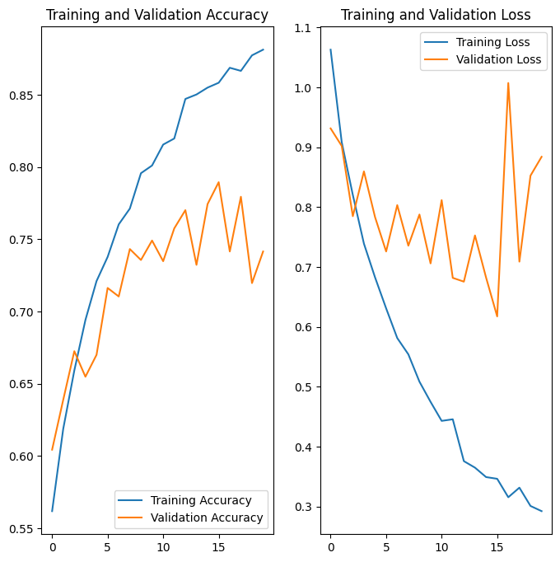The given below Figure 3 is show the illustrates two plots tracking the **training and validation accuracy** and **training and validation loss** of a machine learning model across epochs.

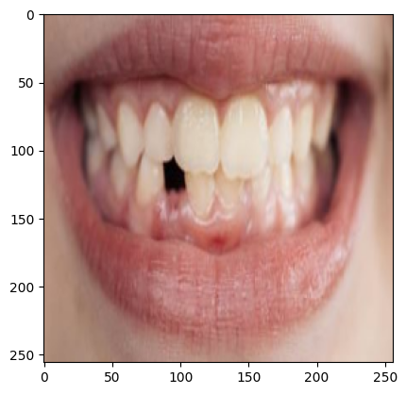

Figure 3: Training and Validation Accuracy Figure 4: While Training Image

Here's a detailed analysis:

**Observation:**The training accuracy (blue line) consistently increases over epochs, reaching above 0.85, indicating that the model is learning the training data effectively.

The validation accuracy (orange line) improves initially, fluctuates significantly after a few epochs, and does not reach the same level as the training accuracy.

**Interpretation:**The gap between training and validation accuracy suggests overfitting: the model is performing well on the training data but not generalizing effectively to the validation data.

Fluctuations in validation accuracy could indicate that the model is sensitive to specific samples or noise in the validation set.

**Training and Validation Loss**

**Observation:**The training loss (blue line) steadily decreases, which is expected as the model optimizes during training.

The validation loss (orange line) decreases initially but starts fluctuating and shows a tendency to increase in later epochs.

**Interpretation:**The decrease in training loss indicates effective learning on the training data.

The increase in validation loss combined with fluctuating accuracy is a clear sign of overfitting. The model might be memorizing training data rather than learning generalizable patterns.

**Key Issues**

**Overfitting:** The model performs better on the training data than on the validation data.

**Fluctuations in Validation Metrics:** Suggests potential issues with the data (e.g., insufficient data, noisy labels, or class imbalance).

**Main Functionality of the Oral Disease Detection App**

**Login and Signup:**The app provides a secure user authentication system, allowing users to sign up by creating an account with a unique username and password.

Registered users can log in to access the app’s features. This ensures personalized and secure access to the system.

**Upload Images and Diagnosis:**Users can upload images of their oral condition (e.g., teeth, gums, or mouth) through the app.

The uploaded image is processed by a pre-trained machine learning model to identify potential oral diseases.

The system provides a diagnosis by detecting conditions such as Calculus, Data Caries, Gingivitis, Mouth Ulcers, Tooth Discoloration, or Hypodontia.

Along with the diagnosis, users receive a confidence score and personalized suggestions for managing the detected condition, helping them take proactive steps for their oral health.

**Chat with Dentist Chatbot:**The app integrates an AI chatbot powered by advanced generative models to simulate conversations with a virtual "dentist."

Users can ask the chatbot questions about their diagnosis, general oral health tips, or specific queries about dental hygiene and treatment.

The chatbot enhances user engagement by providing quick, accessible, and informative responses, making the app an interactive resource for oral health education.

This combination of functionalities ensures a seamless user experience, guiding individuals from logging in to receiving a diagnosis and engaging with AI-powered support for better oral health management.

Output of the Sytem is here:

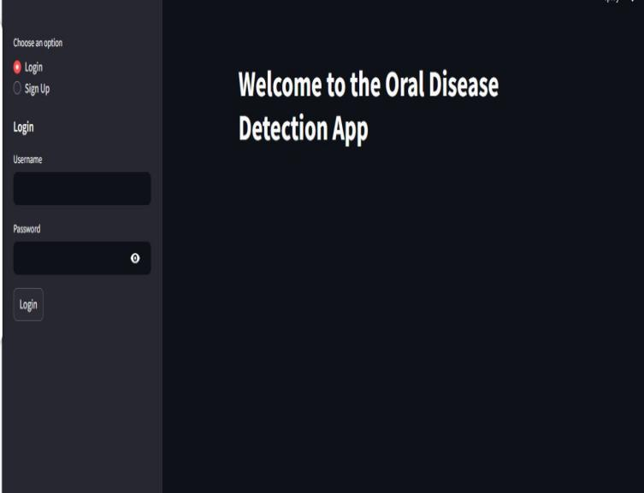

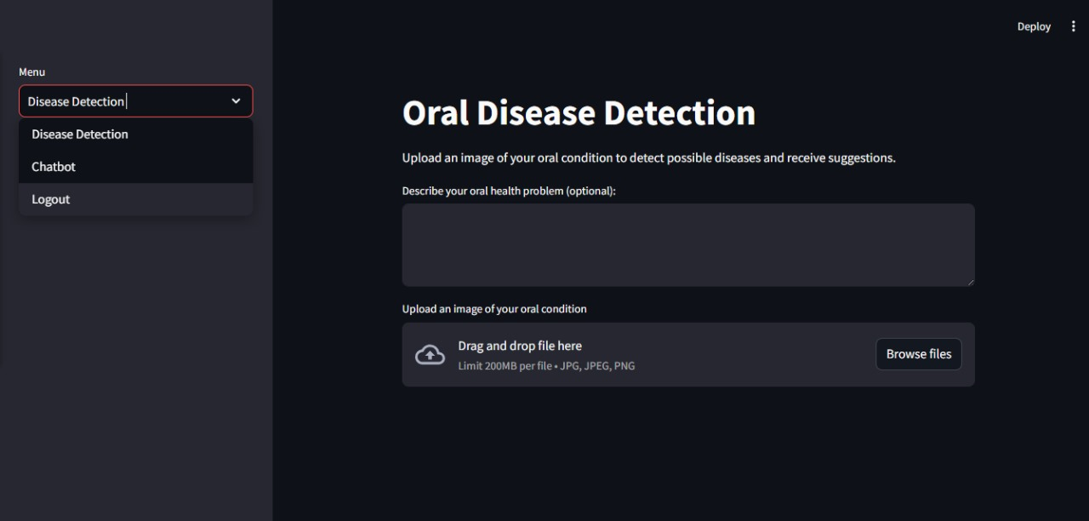

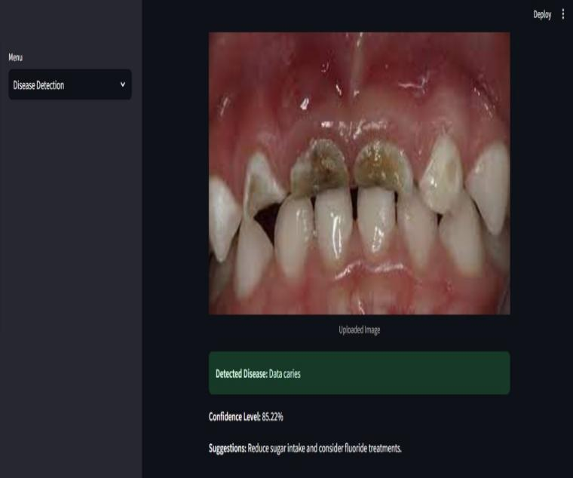

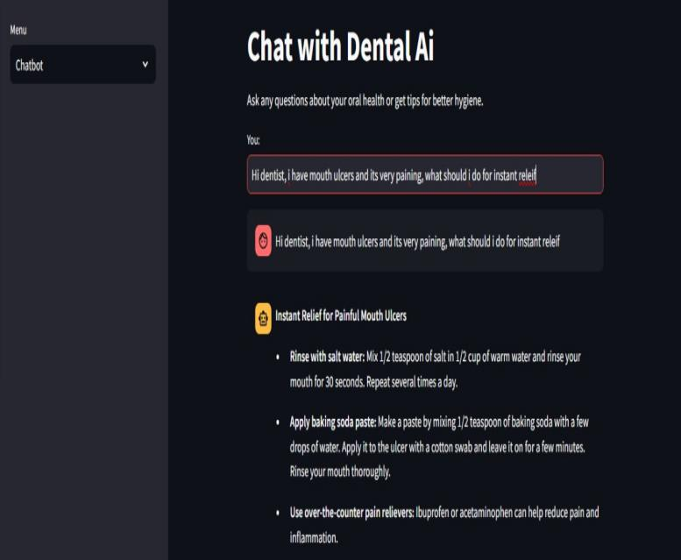

**Conclusion**

The Oral Disease Detection App represents a significant step forward in leveraging artificial intelligence for enhancing oral health care. By combining cutting-edge technologies like TensorFlow and Streamlit with AI-driven chatbot support, the app provides an accessible, cost-effective, and user-friendly platform for early detection of oral diseases. It empowers users with timely insights, educational resources, and actionable guidance to improve oral hygiene and reduce the risk of severe dental complications. This innovative solution bridges the gap in healthcare accessibility, particularly for underserved communities, while promoting a proactive approach to maintaining oral health.